## **CHAUDHARY HAMDAN**

**1905387**

**OOP LAB-3**

**Date : 14-08-2020**

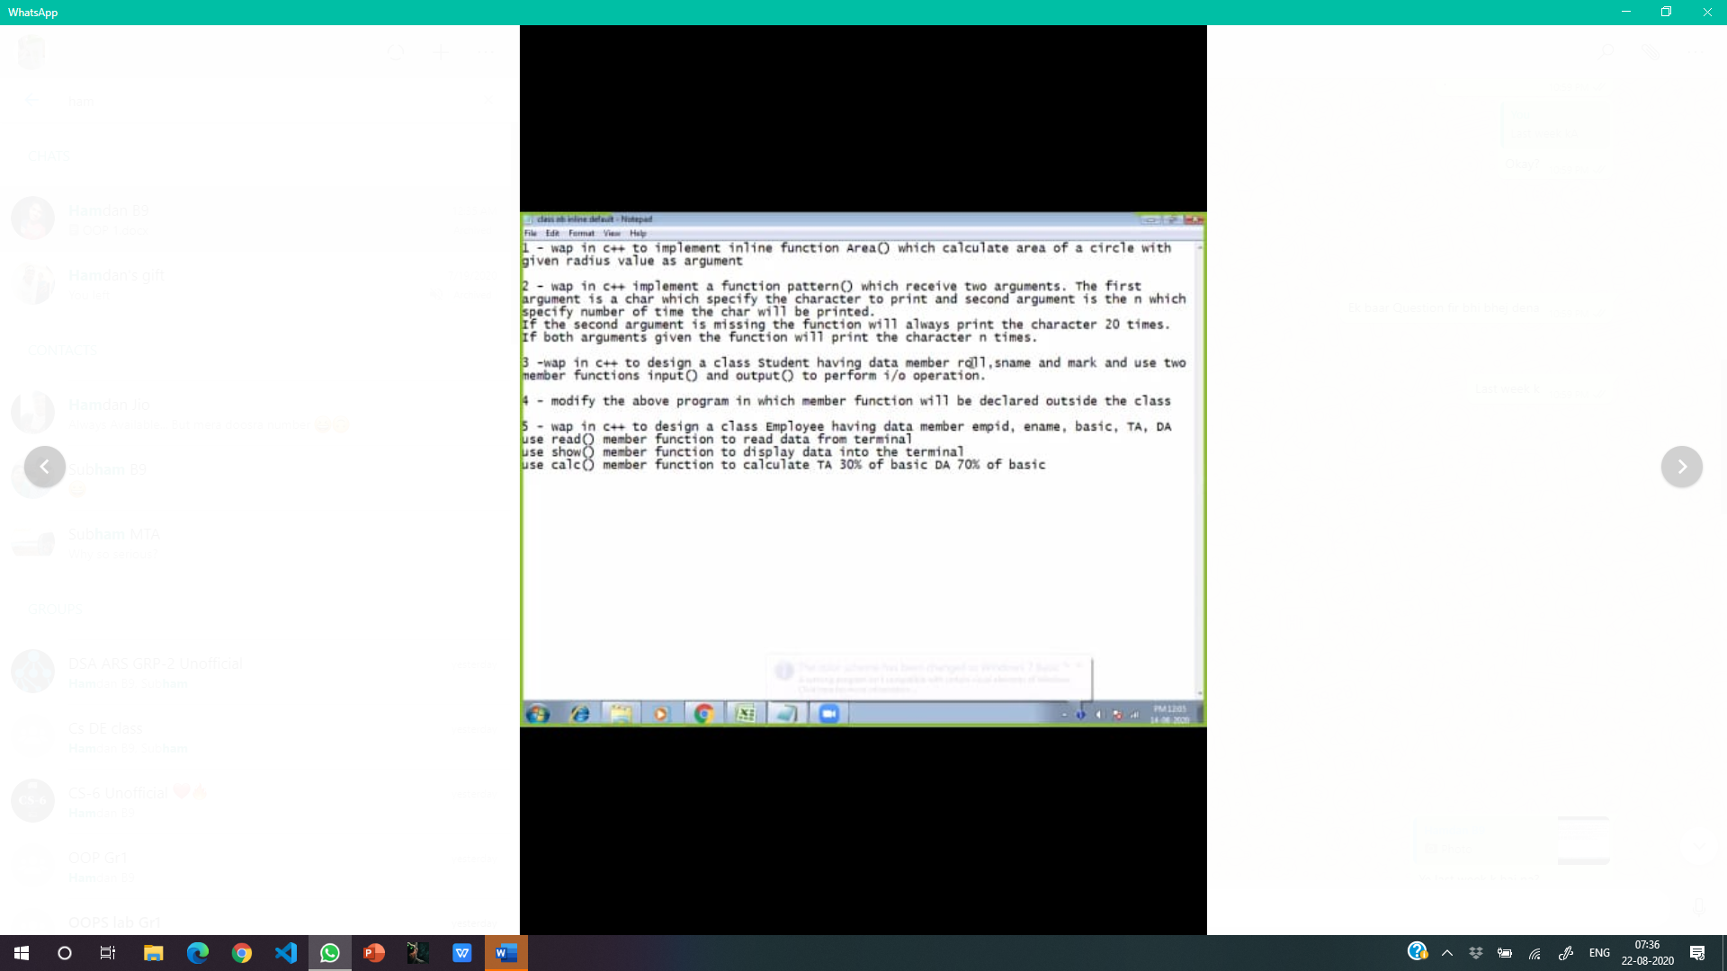

**1.**

**#include<iostream>**

**using namespace std;**

**inline float area(int r)**

**{**

**return (3.14*r*r);**

**}**

**int main()**

**{**

**int rad;**

**cout<<"Enter radius of the circle\n";**

**cin>>rad;**

**cout<<"Area of the circle is "<<area(rad)<<endl;**

**}**

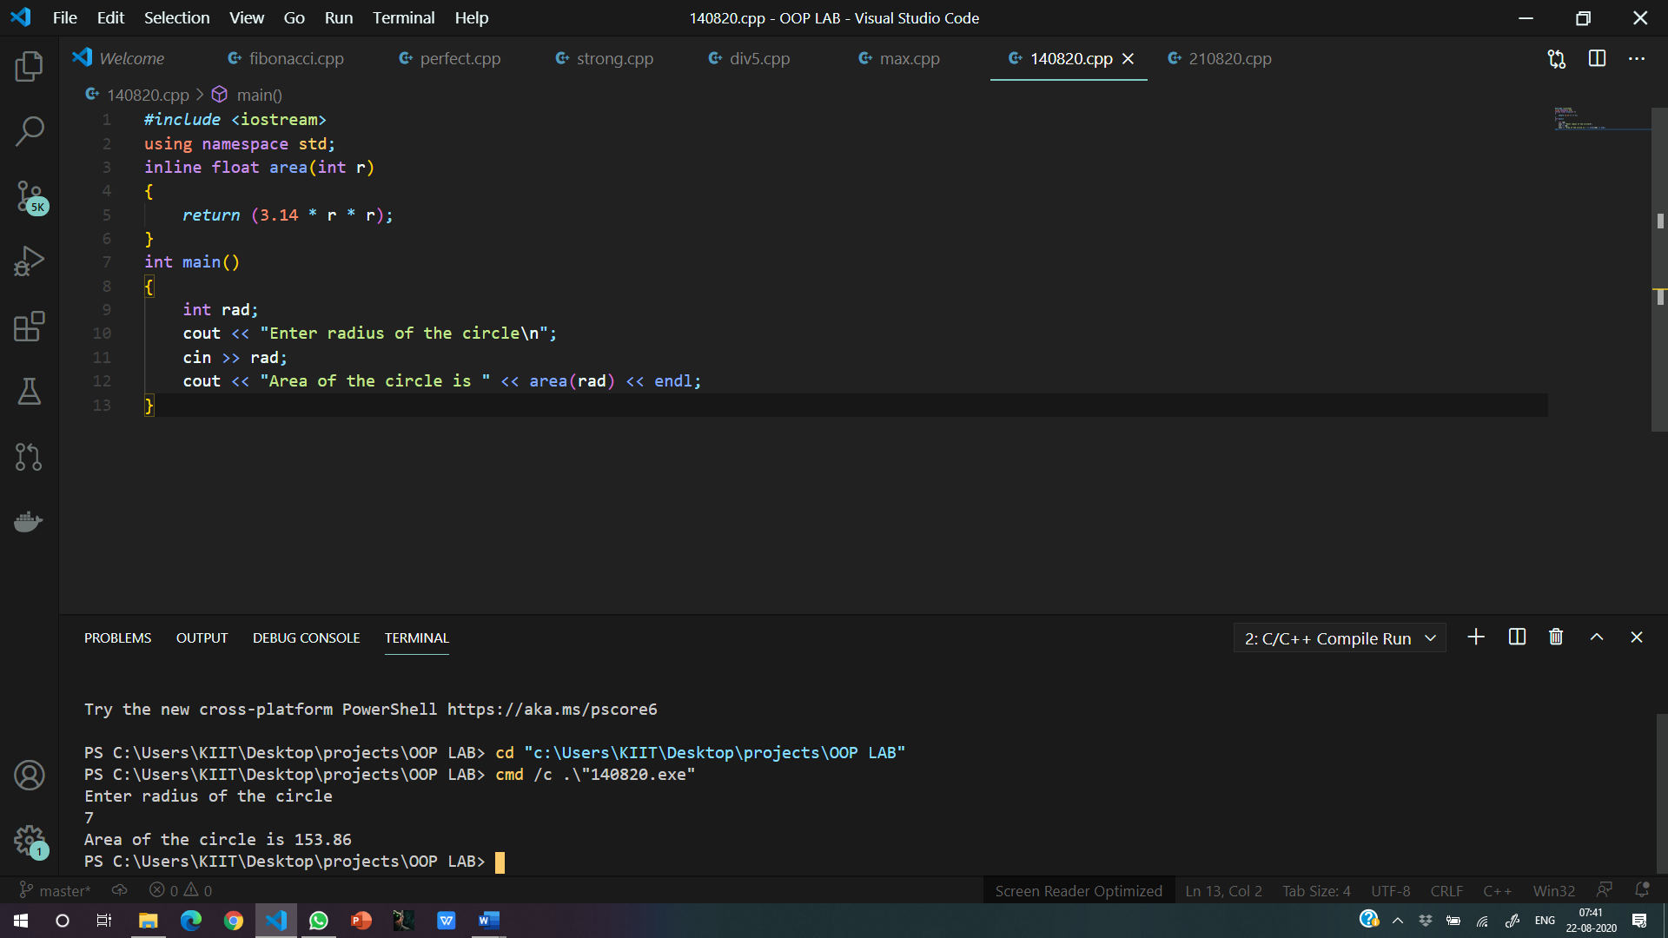

**2.**

**#include<iostream>**

**using namespace std;**

**void pattern(char c,int n=20)**

**{**

**for(int i=0;i<n;i++)**

**{**

**cout<<c<<"\t";**

**}**

**cout<<endl;**

**}**

**int main()**

**{**

**int n;char c;**

**cout<<"Enter the character and no. of times\n";**

**cin>>c>>n;**

**pattern(c,n);**

**pattern(c);**

**}**

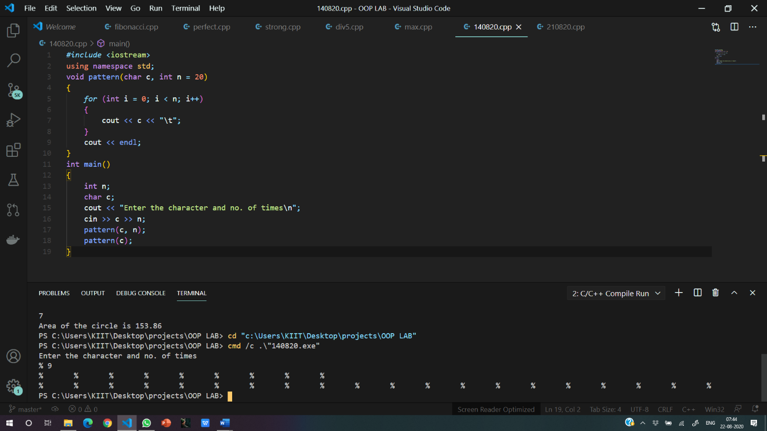

**3.**

#include<iostream>

#include<string>

using namespace std;

class Student

{

int roll;

string name;

int mark;

public:

void input()

{

cout<<"Enter The Roll No.\n";

cin>>roll;

cout<<"Enter Name \n";

cin>>name;

cout<<"Enter marks in one subject\n";

cin>>mark;

}

void display()

{

cout<<"Name: "<<name<<endl;

cout<<"Roll No.: "<<roll;

cout<<"\tMarks: "<<mark<<endl;

}

};

int main()

{

Student obj;

obj.input();

obj.display();

return 0;

}

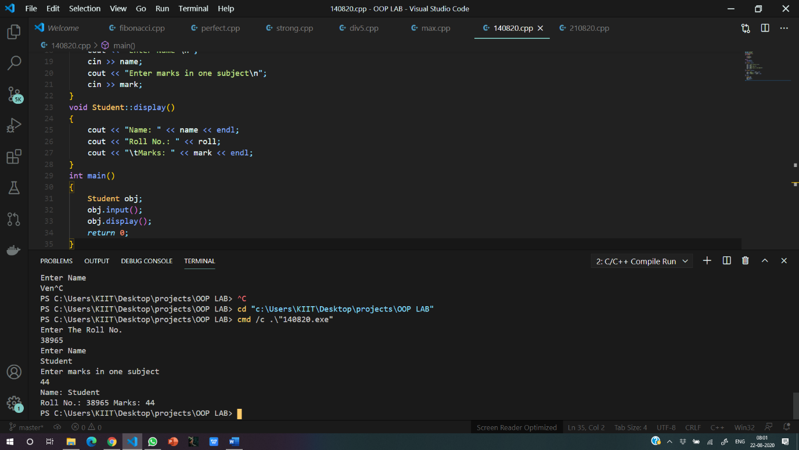

4.

#include<iostream>

#include<string>

using namespace std;

class Student

{

int roll;

string name;

int mark;

public:

void input();

void display();

};

void Student::input()

{

cout<<"Enter The Roll No.\n";

cin>>roll;

cout<<"Enter Name \n";

cin>>name;

cout<<"Enter marks in one subject\n";

cin>>mark;

}

void Student::display()

{

cout<<"Name: "<<name<<endl;

cout<<"Roll No.: "<<roll;

cout<<"\tMarks: "<<mark<<endl;

}

int main()

{

Student obj;

obj.input();

obj.display();

return 0;

}



**5.**

#include<iostream>

#include<string>

using namespace std;

class Student

{

int empid;

string name;

int basic;

float ta,da;

public:

void read();

void show();

void calc();

};

void Student::read()

{

cout<<"Enter The Employee Id\n";

cin>>empid;

cout<<"Enter Name \n";

cin>>name;

cout<<"Enter Basic Salary\n";

cin>>basic;

}

void Student::show()

{

cout<<"Name: "<<name;

cout<<"\tEmp Id: "<<empid<<endl;

cout<<"Basic Salary: "<<basic<<endl;

cout<<"TA: "<<ta;

cout<<"\tDA: "<<da<<endl;

}

void Student::calc()

{

ta = 0.3*basic;

da=0.7*basic;

}

int main()

{

Student obj;

obj.read();

obj.calc();

obj.show();

return 0;

}

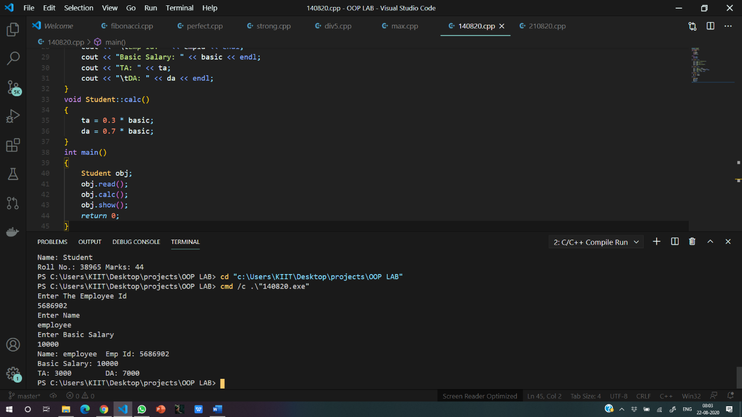

1. WAP to swap private data member of two classes.

[The classes have no relation with each other].

#include <iostream>

using namespace std;

class B;

class A

{

public:

int x = 10;

friend class B;

};

class B

{

public :

int y=20;

friend class A;

void swapp(A &ob)

{

ob.x = ob.x+y;

y=ob.x-y;

ob.x=ob.x-y;

}

};

int main()

{

A ob1;

B ob;

cout << ob1.x << " " << ob.y << endl;

ob.swapp(ob1);

cout << ob1.x << " " << ob.y << endl;

return 0;

}

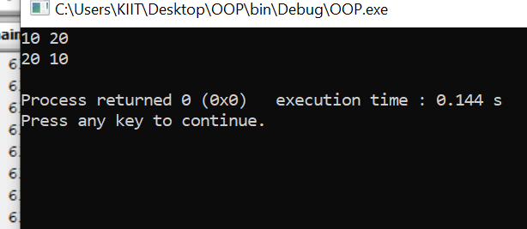

7. Create two classes which stores distance in feet, inches and meter, centimeter format

respectively. Write a function which compares distance in object of these classes and

displays the larger one.

#include<iostream>

using namespace std;

class Met;

class inc{

float feet, inches;

public:

float total;

void getdata(){

cout<<"Enter the distance in feet and inches: "<<endl;

cin>>feet;

cin>>inches;

total = (feet * 12) + inches;

total = total * 2.54;

}

friend void calc(Met, inc);

};

class Met{

float met, cent;

public:

float total;

void getdata(){

cout<<"Enter the distance in metres and centimetres: "<<endl;

cin>>met;

cin>>cent;

total = met * 100 + cent;

}

friend void calc(Met, inc);

};

void calc(Met m, inc i){

if(m.total > i.total){

cout<<"The larger of distances is "<<m.met<<" metres and "<<m.cent<<" centimetres."<<endl;

}

else{

cout<<"The larger of distances is "<<i.feet<<" feet and "<<i.inches<<" inches."<<endl;

}

}

int main(){

Met m;

inc i;

m.getdata();

i.getdata();

calc(m, i);

return 0;

}

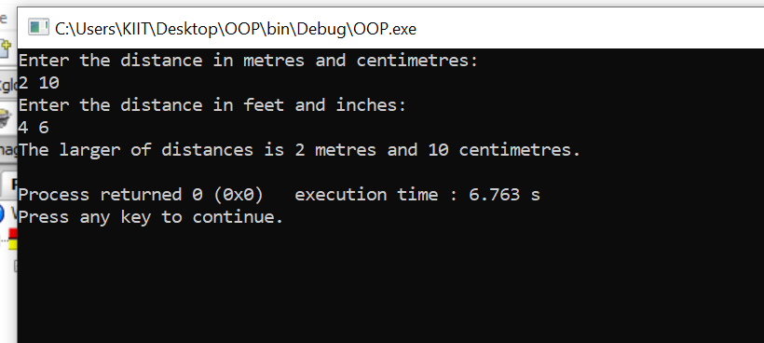

8. Create a class with an integer data member. Include functions for input and output in

class. Count the number of times each function is called and display it.

#include <iostream>

using namespace std;

class A

{

static int c;

static void countt()

{

c++;

}

public :

static void display()

{

countt();

cout << c << endl;

}

};

int A :: c;

int main()

{

A :: display();

A :: display();

A :: display();

A :: display();

A :: display();

return 0;

}

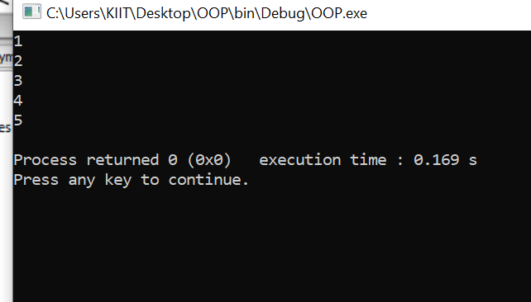

9. Create a class which stores name, roll number and total marks for a student. Input data for

n students. Find the average marks scored by n students, store it as a data member of

the class and display it using a function which may be called without object.

#include <iostream>

using namespace std;

class students

{

string name;

int roll;

int tmarks;

static int avgMarks;

public:

void getdata()

{

cout<<"Enter Name: ";

cin>>name;

cout<<"Enter Roll: ";

cin>>roll;

cout<<"Enter Total Marks: ";

cin>>tmarks;

}

static void display(students obj[],int n)

{

for(int i=0; i<n; i++)

{

avgMarks=avgMarks+obj[i].tmarks;

}

cout<<"\nAverage marks of the students : "<<(avgMarks/n);

}

};

int students::avgMarks=0;

int main()

{

int n;

cout<<"Enter number of students: ";

cin>>n;

students ob[n];

for(int i=0; i<n; i++)

{

ob[i].getdata();

}

cout << "\n\n";

students::display(ob,n);

return 0;

}

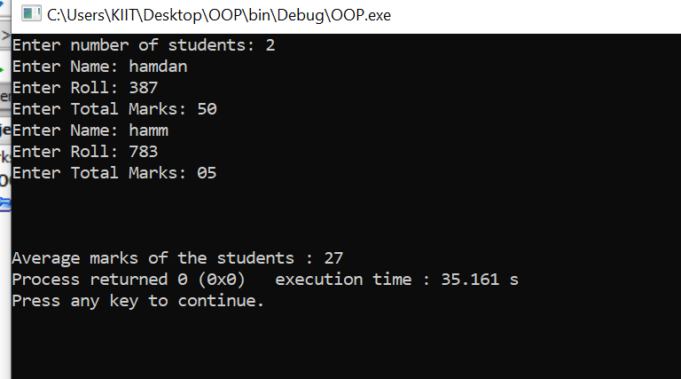

10. Create a class which stores name, author and price of a book. Store information for n

number of books. Display information of all the books in a given price range using

friend function.

#include<iostream>

#include<iomanip>

#include<string.h>

using namespace std;

class bookstore{

string name;

string author;

float price;

public:

void getbooks(){

cout<<"Enter the name of the book: "<<endl;

cin>>name;

cout<<"Enter the author: "<<endl;

cin>>author;

cout<<"Enter the price: "<<endl;

cin>>price;

}

friend void check(bookstore b[], int n);

};

void check(bookstore b[], int n){

int i;

int low, up;

cout<<"Enter the lower index of the price range: "<<endl;

cin>>low;

cout<<"Enter the upper index of the price range: "<<endl;

cin>>up;

cout<<"\nThe books in the range "<<low<<" to "<<up<<" are: "<<endl;

for( i = 0; i < n; i++){

if(b[i].price >= low && b[i].price <= up){

cout<<"\nName of the book"<<right<<setw(3)<<" : "<<right<<setw(5)<<b[i].name<<endl;

cout<<"Author of the book"<<right<<setw(3)<<" : "<<right<<setw(5)<<b[i].author<<endl;

cout<<"Price of the book"<<right<<setw(3)<<" : "<<right<<setw(5)<<b[i].price<<endl;

}

else

{

cout<<"No books are in this price range."<<endl;

}

}

}

int main(){

int n, i;

cout<<"Enter the number of books: "<<endl;

cin>>n;

bookstore b[n];

for(i = 0; i < n; i++){

b[i].getbooks();

}

check(b, n);

return 0;

}

